Statistics from the 2017 PPE Admissions Round
For 2018 Entry

In 2017 we received 2218 applications for PPE. 728 applicants (33%) were shortlisted for interview. 272 offers of places were made (including Open Offers and Deferred Offers). 12% of all applicants, and 37% of shortlisted applicants, were successful. 2101 (95%) applicants successfully registered for and sat the TSA admissions test. 0 applicants who had not sat the TSA were interviewed and offered a place. 50 applicants applied for deferred entry. Of these, 12 were interviewed and 5 received an offer for 2019.

1 Shortlisting
The factors involved in shortlisting applicants have the following levels of importance:
- High Importance: TSA; GCSE (or similar) profile; predicted performance at A-Level (or equivalent)
- Medium Importance: UCAS reference
- Low Importance: AS Level module grades (or equivalent); UCAS personal statement

Admissions tutors use the full set of information on GCSE performance, including 7/A and 9/8/A* grades. They also use GCSE performance data to assess whether an applicant's grades reflect an under- or over-performance within the context of their school (see the contextual data page on the University website for further information about how contextual data is used).

Figure 1 shows the distribution of the marks in each component of the TSA for applicants who were not interviewed, those interviewed but not offered a place, and those offered a place.

Figure 1: TSA Marks

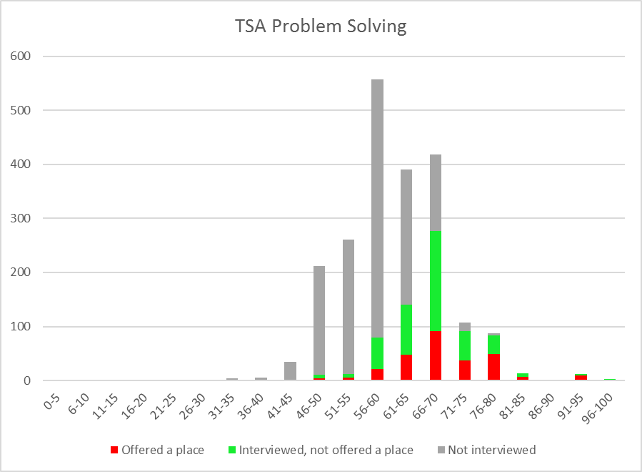

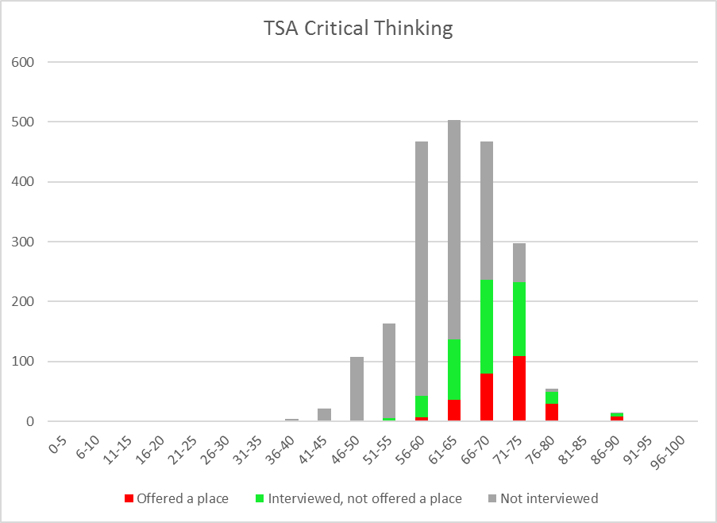

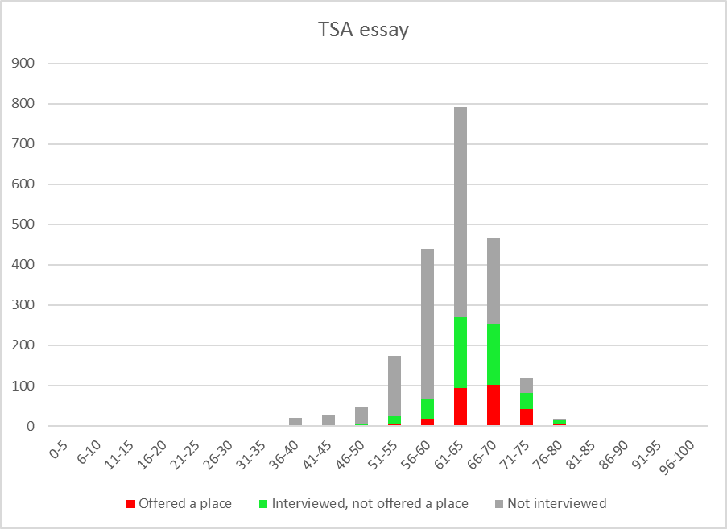

Figure 2 shows the distribution of the number of 7/A's and 9/8/A*'s (panel (a)) and 9/8/A*'s (panel (b)) at GCSE for applicants who were not interviewed, those interviewed but not offered a place, and those offered a place.

Figure 2: GCSE Grades

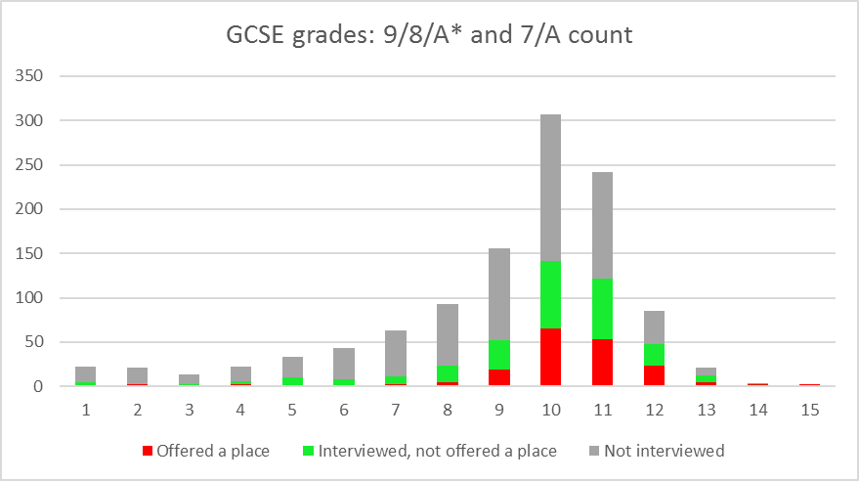

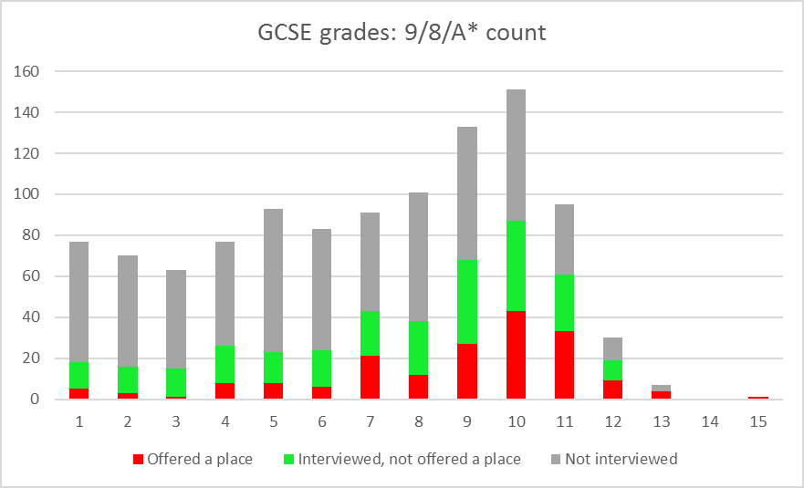

Figure 3 shows the distribution of the number of predicted A*'s at A-Level for applicants who were not interviewed, those interviewed but not offered a place, and those offered a place.

Figure 3: Predicted and Achieved A-Level Grades

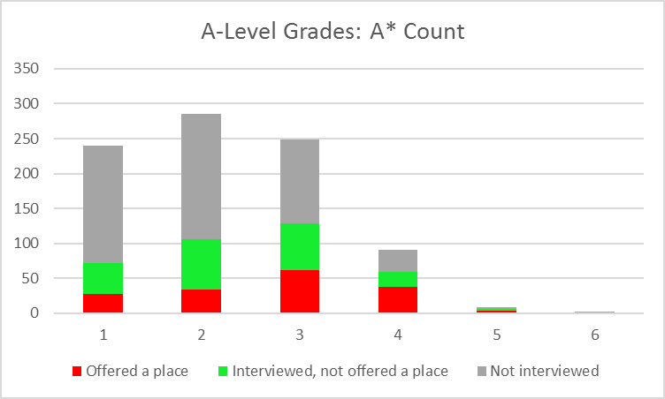

2 Interviews & Offers
The characteristics being judged in interview are:
- Application and interest: capacity for sustained study, motivation and interest, an independent and reflective approach to learning;
- Reasoning ability: ability to analyse and solve problems using logical and critical approaches, ability to assess relevance, capacity to construct and critically assess arguments, flexibility and willingness to consider alternative views;
- Communication: willingness and ability to express ideas clearly and effectively on paper and orally; ability to listen; ability to give considered responses.

3 A-level Subjects
1032 (47%) applicants offered A-levels. Applicants for PPE may have done any combination of subjects at school. History and Maths are useful backgrounds, but are considered not essential.

Maths

Although a background in Maths is not formally required for admission, PPE applicants should have sufficient interest in, and aptitude for, maths to cope with the mathematical elements of the course. Maths is a particular advantage for the Economics component of the course, as well as for the first year logic course in Philosophy, and for understanding theories and data in Politics.

Of the 1032 applicants offering A-Levels, 852 had Maths (or Maths and Further Maths). Of the 417 applicants offering A-Levels who were interviewed, 373 (89%) had Maths. Of the 179 applicants offering A-Levels who were awarded a place, 170 (95%) had Maths.

The following diagrams show the distribution of marks in the three components of the TSA for A-Level applicants with and without A-Level Maths. The average marks for A-Level applicants with Maths were 61.9, 63.7, and 63.6 in the Problem Solving, Critical Thinking, and Essay components respectively. For A-Level applicants without Maths, the average marks were 60.0 62.0, and 61.5.

Figure 4: TSA Marks

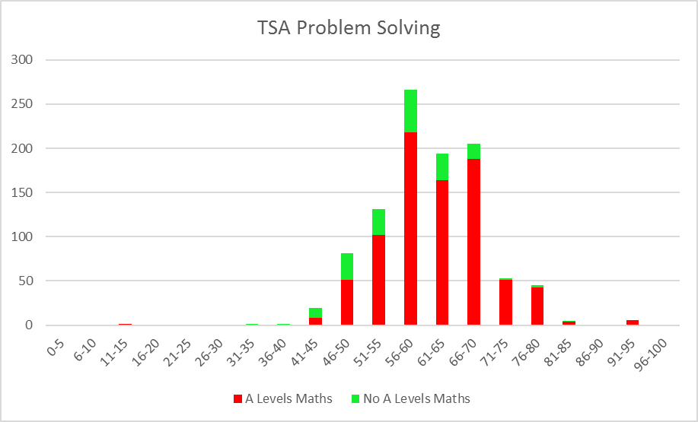

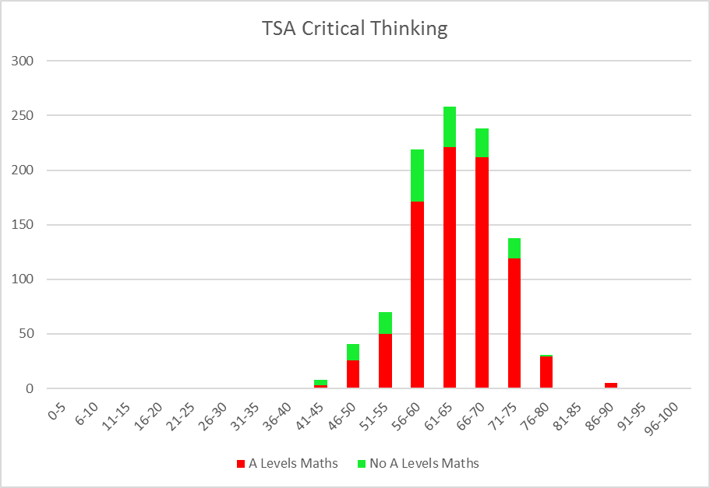
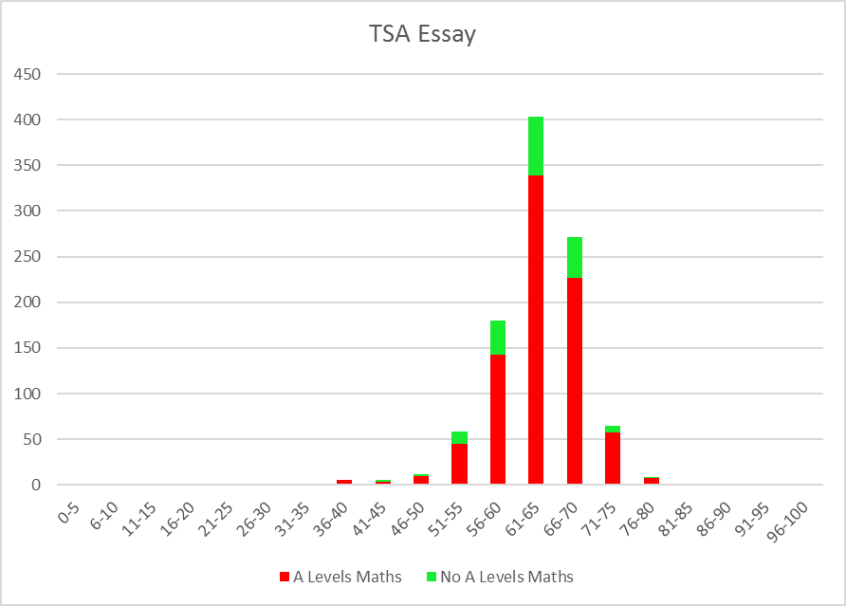

History
Of the 1032 applicants offering A-Levels, 369 (36%) had A-Level History. Of the 417 applicants offering A-Levels who were interviewed, 166 (40%) had History. Of the 179 applicants offering A-Levels who were awarded a place, 47 (26%) had History.

PPE
756 applicants (76%) offered at least one A-Level in either Philosophy, Politics/Government, or Economics. Of the 179 applicants offering A-Levels who were awarded places, 120 (67%) had at least one of these subjects. Economics was the most popular of these subjects. It was offered by 620 applicants of those studying A-Levels (60%) and by 97 (54%) of those awarded places. Politics/Government was offered by 303 applicants, and Philosophy by 48 applicants. 8 applicants offered A-Levels in all three subjects.

4 International Applicants
There were 728 (33%) non-EU international applicants. Of these, 210 were shortlisted for interview (29% of all shortlisted), and 60 were offered places (22% of all placed).

Figure 5: TSA Marks

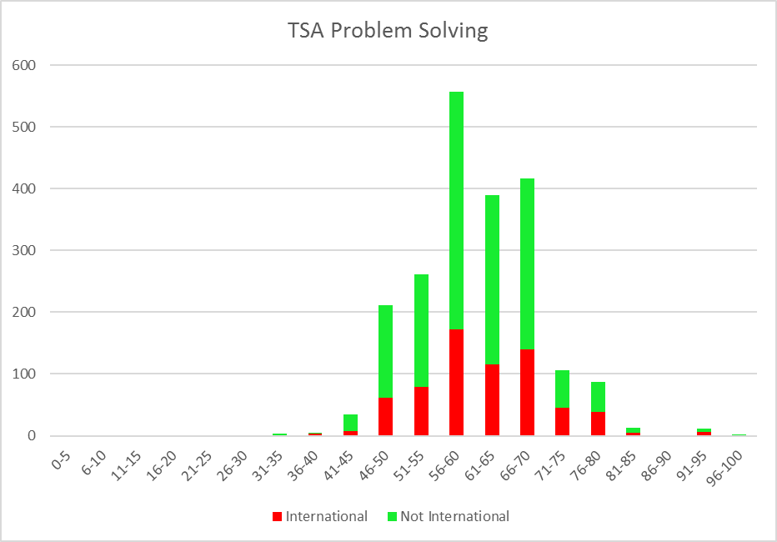

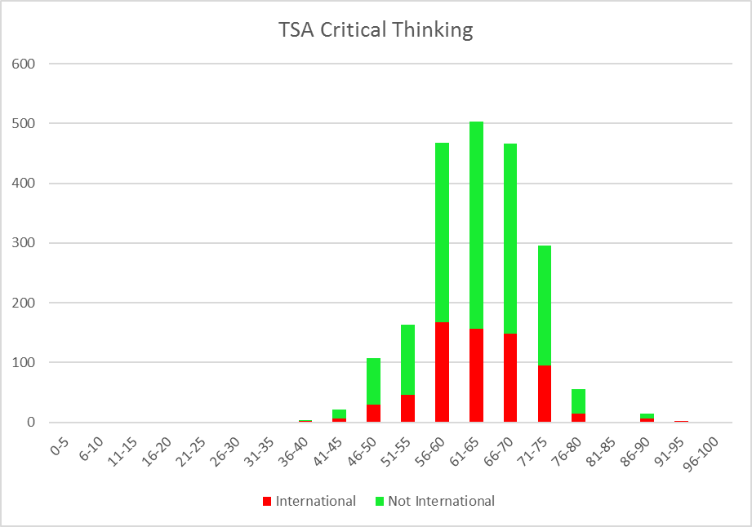

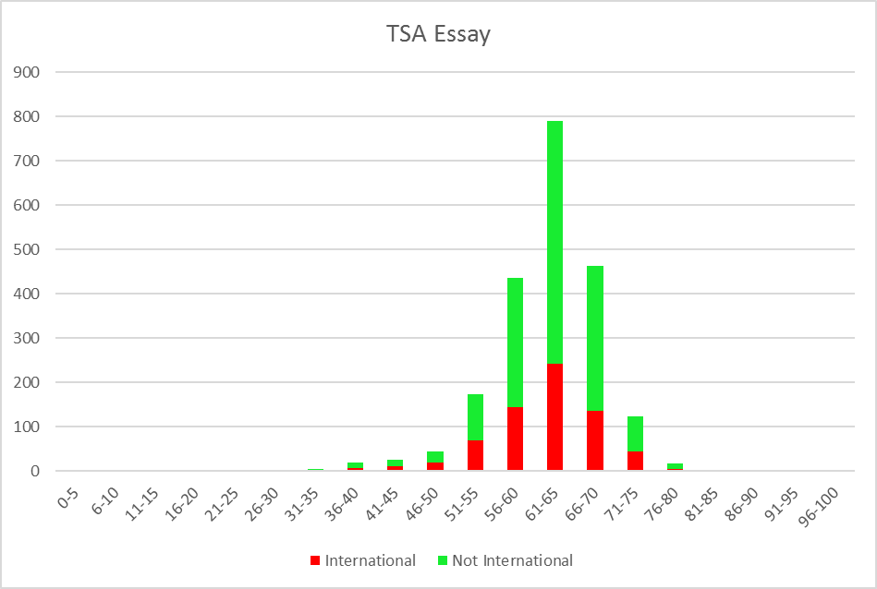

Applicants awarded Open Offers are guaranteed a place, subject to the conditions attached to the offer. However, their college is not decided until after exam results are released.
Applicants awarded Deferred Offers are guaranteed a place, subject to the conditions of the offer, but start the course a year later than applicants awarded normal offers.

