PPE admissions 2020-21
Further statistics

These statistics are a supplement to the preliminary statistics published on the admissions statistics page of the PPE course website. 2171 (94%) applicants successfully registered for and sat the TSA admissions test. 7 applicants who had not sat the TSA were interviewed and offered a place. 57 applicants applied for deferred entry. Of these, 20 were interviewed and 2 received an offer for 2022.

1 Shortlisting
The factors involved in shortlisting applicants have the following levels of importance:

Information | High | Medium | Low
Pre-Interview Admissions Test  (TSA Overall and TSA Essay) | Yes
GCSE (or equivalent) profile  (including cGCSEs) | Yes
Predicted (or actual) performance at  A-Level (or equivalent) | Yes
UCAS teacher’s reference |  | Yes
AS-Level module grades |  |  | Yes
UCAS personal statement |  |  | Yes

Admissions tutors use the full set of information on GCSE performance, including 7/A and 9/8/A* grades. They also use GCSE performance data to assess whether an applicant's grades reflect an under- or over-performance within the context of their school (the contextual data page on the University website has further information about how contextual data is used).

The preliminary statistics show the distribution of the marks in each component of the TSA for applicants who were not interviewed, those interviewed but not offered a place, and those offered a place, as well as the distribution of GCSE grades, contextualised GCSE scores, and A-Level grades.

2 Interviews & Offers
The characteristics being judged in interview are:
- Application and interest: capacity for sustained study, motivation and interest, an independent and reflective approach to learning;
- Reasoning ability: ability to analyse and solve problems using logical and critical approaches, ability to assess relevance, capacity to construct and critically assess arguments, flexibility and willingness to consider alternative views;
- Communication: willingness and ability to express ideas clearly and effectively on paper and orally; ability to listen; ability to give considered responses.

3 A-level Subjects
1173 (51%) applicants offered A-levels. Applicants for PPE may have done any combination of subjects at school. History and Maths are useful backgrounds, but are considered not essential.

Maths

Although a background in Maths is not formally required for admission, PPE applicants should have sufficient interest in, and aptitude for, maths to cope with the mathematical elements of the course. Maths is a particular advantage for the Economics component of the course, as well as for the first year logic course in Philosophy, and for understanding theories and data in Politics.

Of the applicants offering A-Levels, 963 had A-Level Maths (or Maths and Further Maths). Of the 452 applicants offering A-Levels who were interviewed, 398 (88%) had A-Level Maths. Of the 161 applicants offering A-Levels who were awarded a place, 149 (93%) had Maths.

The following diagrams show the distribution of marks in the three components of the TSA for A-Level applicants with and without A-Level Maths. The average marks for A-Level applicants with Maths were 71.4, 72.3, and 63.8 in the Problem Solving, Critical Thinking, and Essay components respectively. For A-Level applicants without Maths, the average marks were 65.3, 67.8, and 63.1.

Figure 4: TSA Marks

TSA Problem Solving
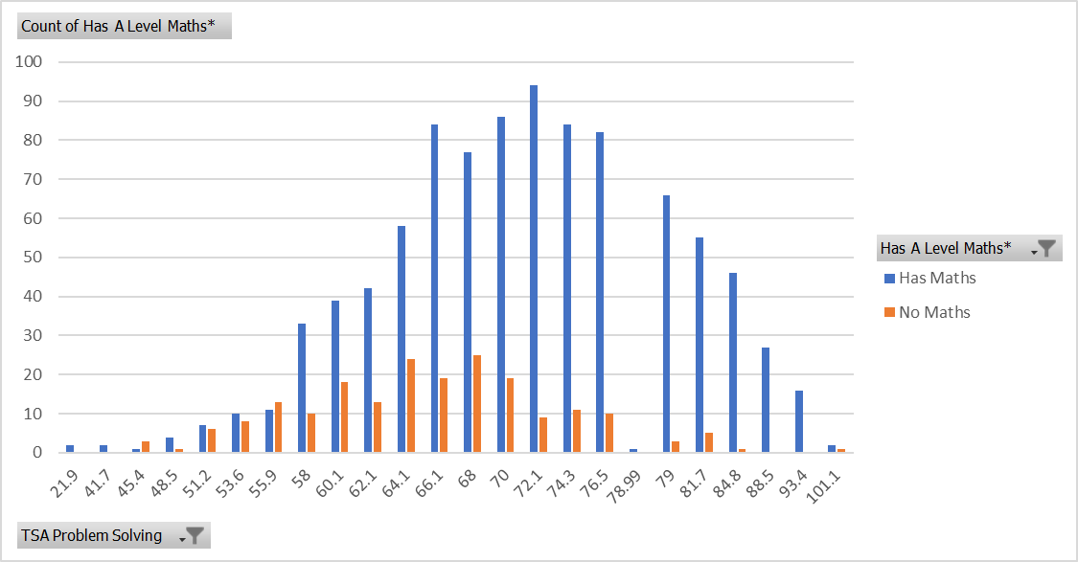

TSA Critical Thinking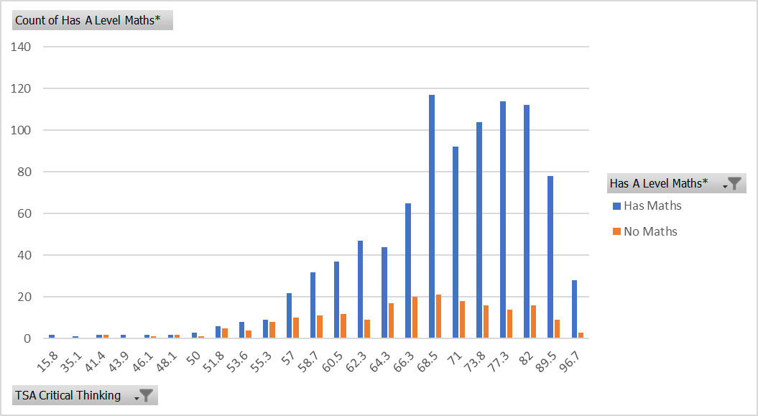
TSA essay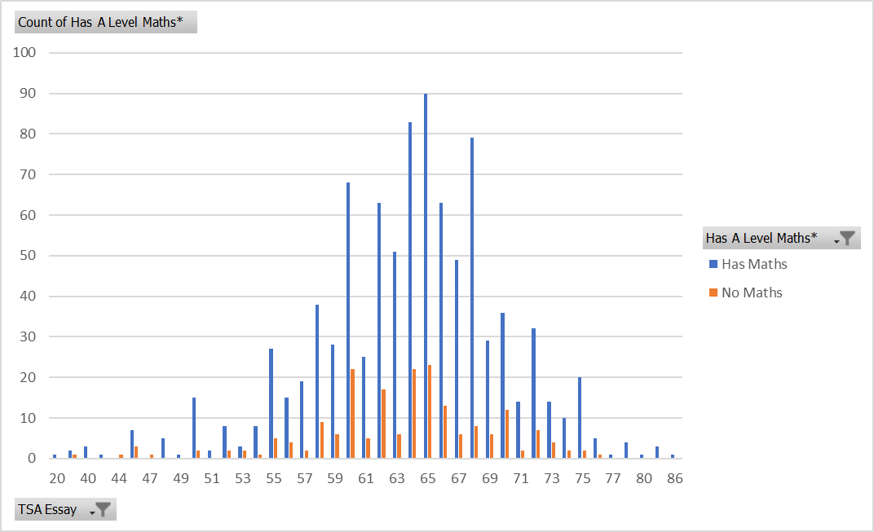

History
Of the applicants offering A-Levels, 419 (36%) had A-Level History. Of the 419 applicants offering A-Levels who were interviewed, 177 (42%) had History. Of the 161 applicants offering A-Levels who were awarded a place, 63 (39%) had History.

PPE
871 applicants (74% of those with A-Levels) offered at least one A-Level in either Philosophy, Politics/Government, or Economics. Of the 161 applicants offering A-Levels who were awarded places, 114 (71%) had at least one of these subjects. Economics was the most popular of these subjects. It was offered by 714 applicants of those studying A-Levels (61%) and by 86 (53%) of those awarded places. Politics/Government was offered by 331 applicants, and Philosophy by 55 applicants. 8 applicants offered A-Levels in all three subjects.

4 International Applicants
There were 897 (39%) non-EU international applicants. Of these, 198 were shortlisted for interview (28% of all shortlisted), and 73 were offered places (28% of all placed).

Figure 5: TSA Marks

TSA Problem Solving
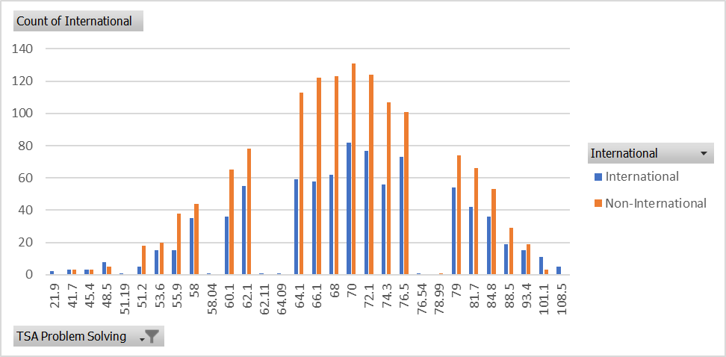

TSA Critical Thinking
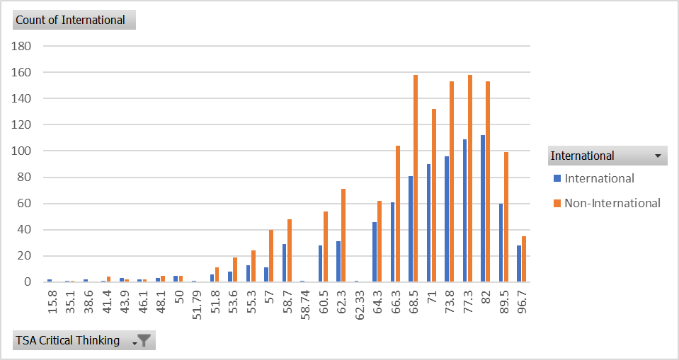

TSA Essay
